//Red color making gula holo, oi style ami korte chassi. Oi khane link dewa ase kindly dekhben.
//Green color marking gula holo main menu r title
//Sign in e Doctor & Staff er registration/login er kaj kore na. kindly eta age kore niyen, then nichen information just design kore bosiye diyen vai.

Contact us: (Total topic cover in 1 page)
Contact us:
Hamdard Clinic Management System
Hamdard Nagar
Gazariya, Munsigonj, Bangladesh
Phone: 01670790971
Email: hcms@gmail.com

IMPORTANT CONTACT NUMBERS:
Emergency: 01970790971
Admission Department: 01770790971
Appointment: 01370790971
Ambulance: 01870790971
Diagnostics: 01570790971

Feedback and Query: (We need this type form given source below)
See the source:
https://www.fortishealthcare.com/contact-us
or,
http://www.sankaranethralaya.org/snapps/Feedback.aspx

About us: (Total topic cover in 1 page)
Mission:
To help the concerned effectively connect with the vast repertoire of healthcare providers in an individually customized manner using internet of things. Thereby, reducing time taken and costs to avail healthcare and increasing clinical outcome levels.

Vision:
We have built an institution which matches the highest standards of healthcare delivery across the world, where care is provided to patients at an affordable cost. HCMS will offer not only the best technical facilities, but also combine the jewel of traditional medicine, and create a medicine which is better than the current medicine. To deliver International Class healthcare with a total service focus, by creating an institution committed to the highest standards of medical & service excellence, patient care, scientific knowledge and medical education.

Leadership & excellence:

At HCMS, we have been providing patients with high-quality, patient-focused medical care. We constantly look for ways to raise the bar on quality healthcare and safety for our patients. HCMS Quality Steering Committee made up of representatives from the hospitals' senior leadership, and leaders of the medical staff, set direction as a continuous process.

Ambulance (Facilities features): (Total topic cover in 1 page)
Overview:
State-of-the-art Ambulances at our hospital are equipped to handle most complex emergencies and are available to our patients round the clock. Our ambulances are equipped with advanced life support systems and carry a doctor on board for cardiac and other life-threatening emergencies.
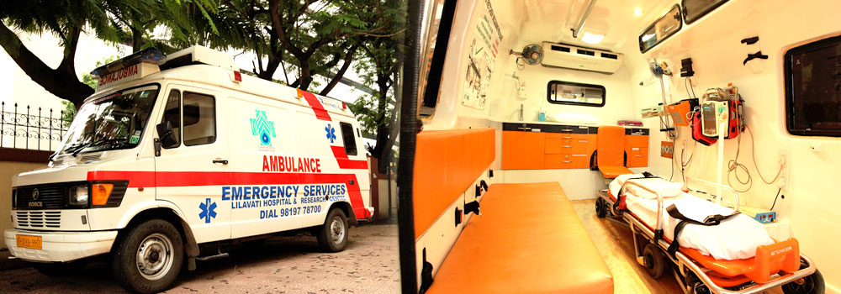
Coverage Area:
Dhaka, Gazipur, Sonargaon, Narayangonj, Munsigonj.
Request Ambulance:
A request for ambulance can be made on payment basis on the following numbers:
Ambulance staff: 09769250010

Hospital shall not be responsible for following:

- Technical problem/ failure of equipment/ breakdown of ambulance.
- Any traffic jam, wrong address given & deadline to reach the destination.
If u need, See the source: http://www.lilavatihospital.com/Critical-Care (jodi ei style paren taile kore diyen na hole apnar esse moto kored iyen vai)

Diagnostics: (2 features: Overview (page 1) & Test (page 2))
Overview: (page-1)
Any successful treatment approach must be founded on a strong, accurate diagnosis, and at Lake Charles Memorial Health System, we remain up to date with the best diagnostic equipment available to ensure that each patient receives the best possible quality of care. Our diagnostic is located on the 1st Floor.
Diagnostics test report receive from report delivery centre, which are located on 1st floor.
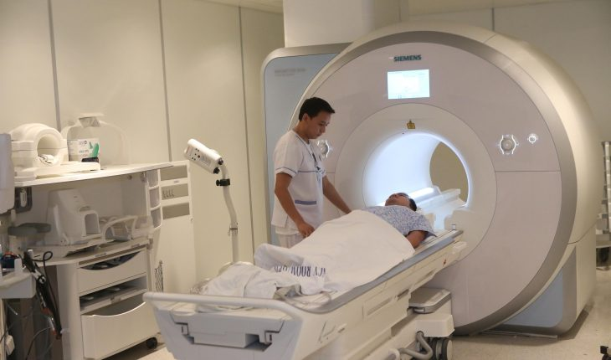

Test: (page-2)
Here our diagnostic test list: (link given below)
Then see the source to make this type.
Source link: http://supermedicalhospital.com/for-patients/test-list/

Visitors: (5 features: welcome note, visiting-hours, parking, cafeteria, location)
Welcome note:
The premier multi-specialty tertiary care hospital of Bangladesh has been acknowledged globally as Centre of medical excellence. The kind of confidence trust it has developed on strong foundation of the state-of-the-art facilities, best medical expertise, research, education and charitable endeavors; that today it serves patients from all walks of life. The hospital has focused its operation on providing quality care with a human touch; which truly reflects the essence of its motto “More than Healthcare, Human Care”.


Visiting-Hours:
Section | Saturday to Thursday | Friday / Public Holidays
ICU / ICCU | 3 PM to 5 PM | 12 PM to 1 PM
Ward | 3 PM to 7 PM | 10 AM to 12 AM / 4 PM to 6 PM

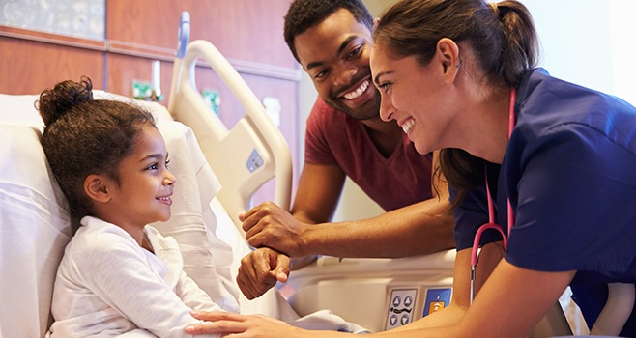

If u need see the source: http://www.lilavatihospital.com/Visiting-Hours

Parking:
For convenience while visiting HCMS, parking service is available to all our patients and visitors, which are located of basement floor. Wheelchairs and other assistance are available for patients and visitors with special needs. Visitor parking is usually full between 08.00 am – 08.00 pm, available every day.
Please note that you do not have to pay for parking, if you leave the parking lot within 30 minutes. If you spend extra times you will able to pay 50 tk for every hour after 30 minutes.
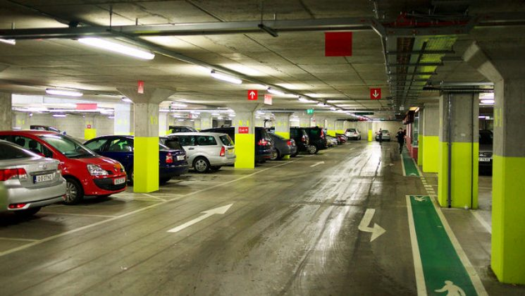

Cafeteria:

Our cafeteria is located on the 2nd Floor. The meals served here are delicious. It is a convenient option for all visitors to have refreshment within hospital premises at a nominal rate. Also, you can get any other beverage like: Coffee, tea, fast food, etc. available in our cafeteria.
Breakfast: 07.00 am to 10.00 pm
Lunch: 12.30 pm to 03.30 pm
Dinner: 08 pm to 11 pm
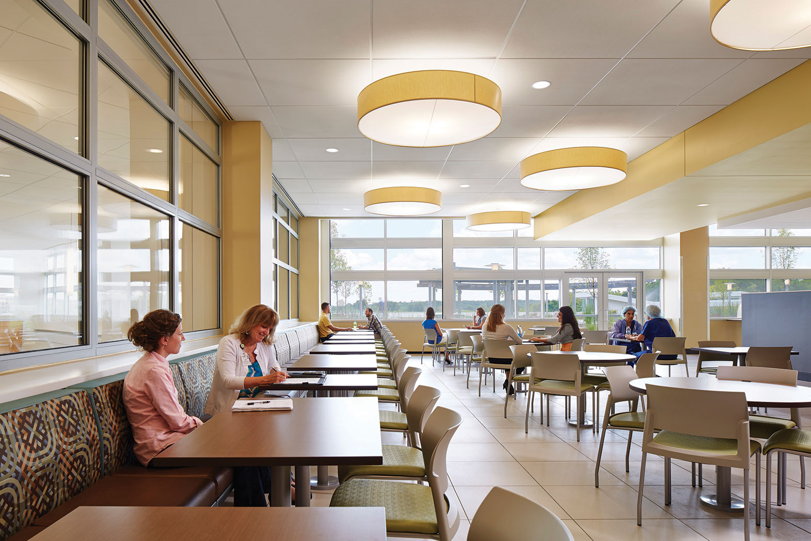

Location:
Address:

Hamdard Clinic Management System
Hamdard Nagar
Gazariya, Munsigonj, Bangladesh
Phone: 01670790971
Email: hcms@gmail.com

Location map:

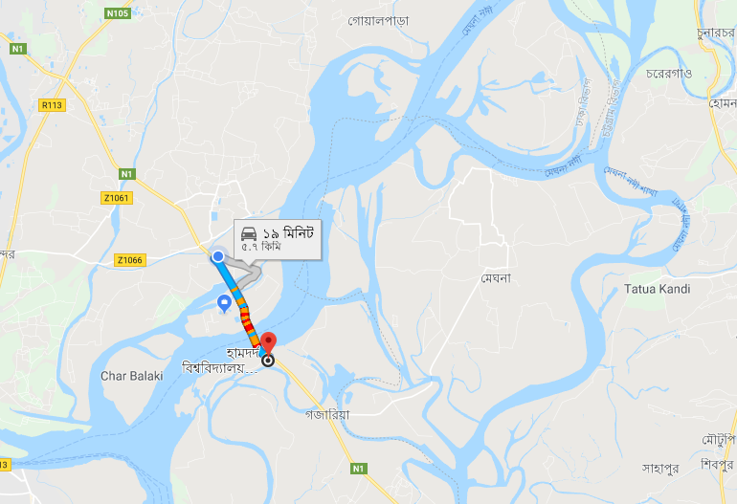

Medicine:
The main pharmacy store is located at the hospital basement whereas the day and night retail pharmacy are located at the ground floor.
The ward pharmacy is strategically located on the every-floor catering to the patients within the hospital.
Our pharmacy is staffed only by qualified and registered pharmacists.
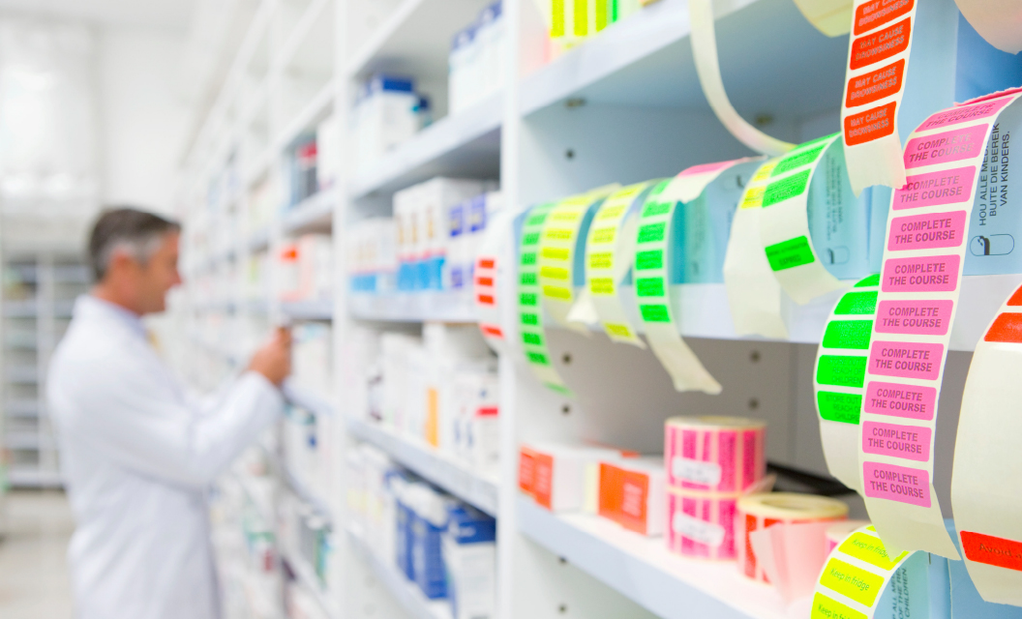

Health tips:
At HCMS we’re thrilled to share our Weekly Wellness tips focused on the mind, the body and healthy eating.
- Wrap yourself in warm clothes, gloves and mufflers to protect yourself from diseases that the Winter season brings itself.
- During Winter it’s important to walk in regular intervals to generate body warmth.
- Wear woollen socks and caps during Winter to protect your feet, head and ears.
- During Winter drink herbal tea and wear mufflers to protect scratchy throat, cold or certain breathing problem.
- A burning feeling when you urinate are signs of urological problems.
- Green Tea reduces LDL cholesterol and triglycerides levels. Drink a cup of green tea once a day.
- Fruits and vegetables provide the body with much needed vitamins and minerals. Include them in your diet to stay active all your life.
- Walk increases blood circulation. Walk for at least 15 minutes daily.
- Stay slim, stay healthy. Keep a tab on your weight to lead a physically fit life.
- Avoid eating fried and highly saturated food items.
- Kick the butt to live a healthy life. Stop smoking to cut down the risk of a heart attack.
- Cut down on alcohol to reduce the risk of heart related ailments.
- Laughter is the best medicine. Laugh to live hale and hearty all your life.
- Include fish in your diet as it is an excellent source of omega-3 that helps to keep heart diseases at bay.
- Foods like cereal and porridge not only help to reduce weight but also keep the heart healthy
- Sleep for at least 6-8 hours daily.
- Keep a tab on blood sugar and cholesterol levels.
- EXERCISE DAILY AS IT HELPS YOU REMAIN FIT.
- CUT DOWN ON SALT INTAKE AS IT INCREASES THE RISK OF DEVELOPING CORONARY HEART AILMENTS.
We want to see health tips this type,
here source: http://www.fortisescorts.in/health-tips?page=2

Available Bed: (Total topic cover in 1 page)

HCMS is now 100 beds with one of the largest Intensive Care Units (ICUs), most advanced 5 Operation Theaters, more than 50 consultants and manpower of nearly 150. Hospital attends to around 300 In-patients and Out-patients daily.
Here 3 types of bed available for patient:

- Premier cabin
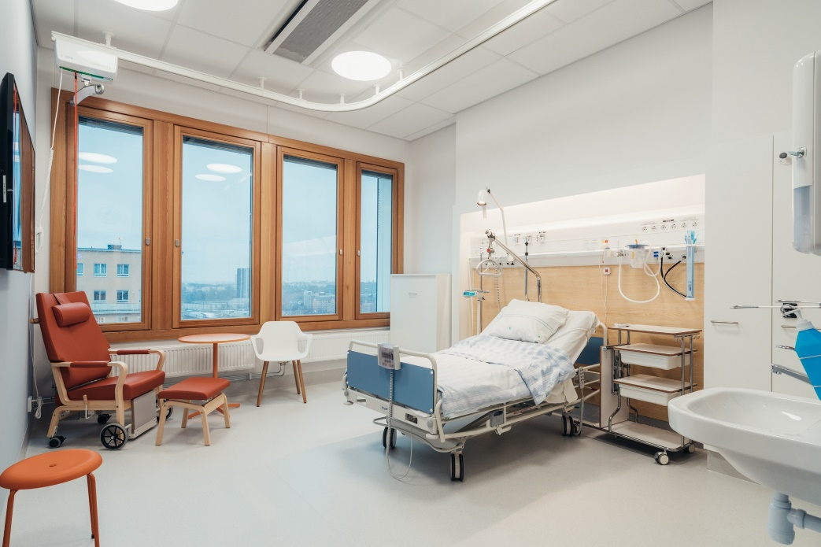
- Cabin
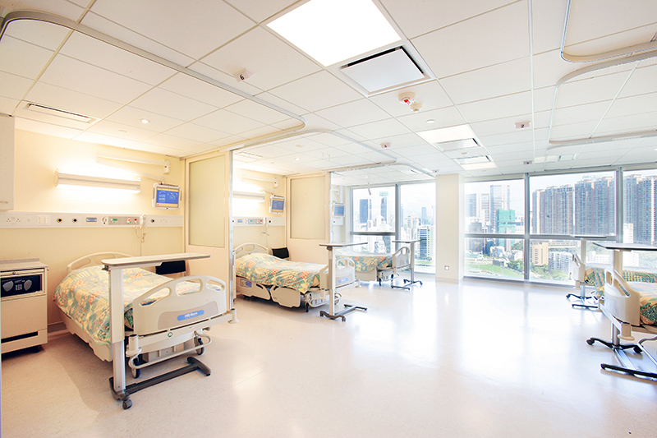

- Ward
